Desktop/Android App: Kanji Study

Kanji Dictionary
+
Flashcard
+
Quiz
Tính năng:

Kanji
Flashcard
User
ReviewSession
QuizQuestion
QuizGame
ProgressTracker

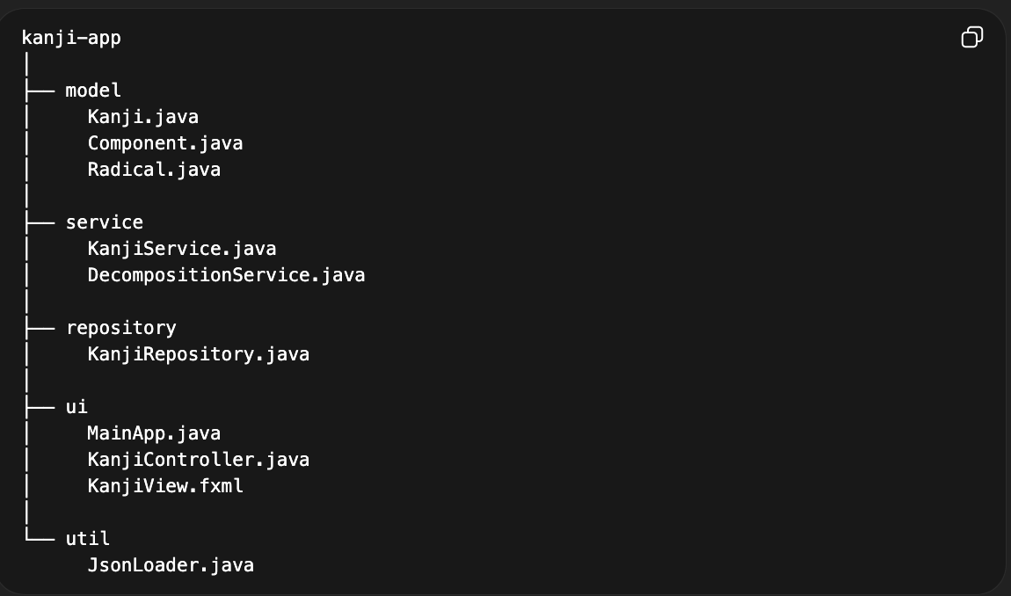
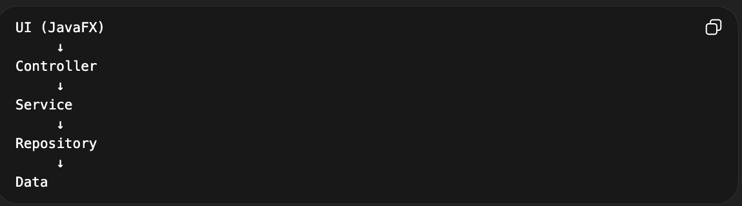
Flow:
Search Kanji
↓
Add to study list
↓
Flashcard review
↓
Quiz test
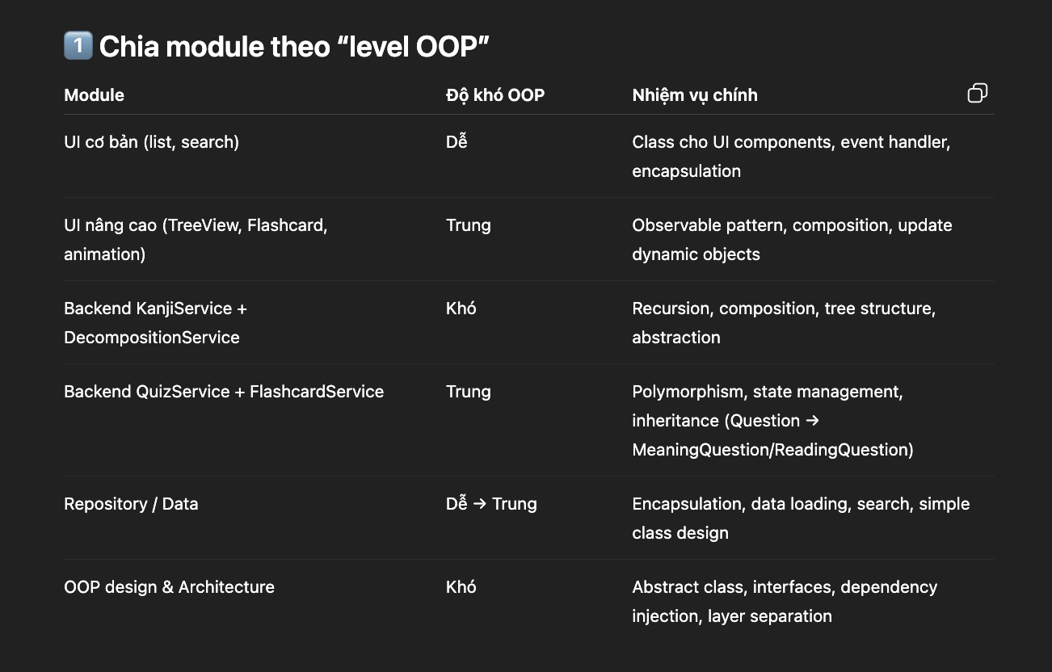
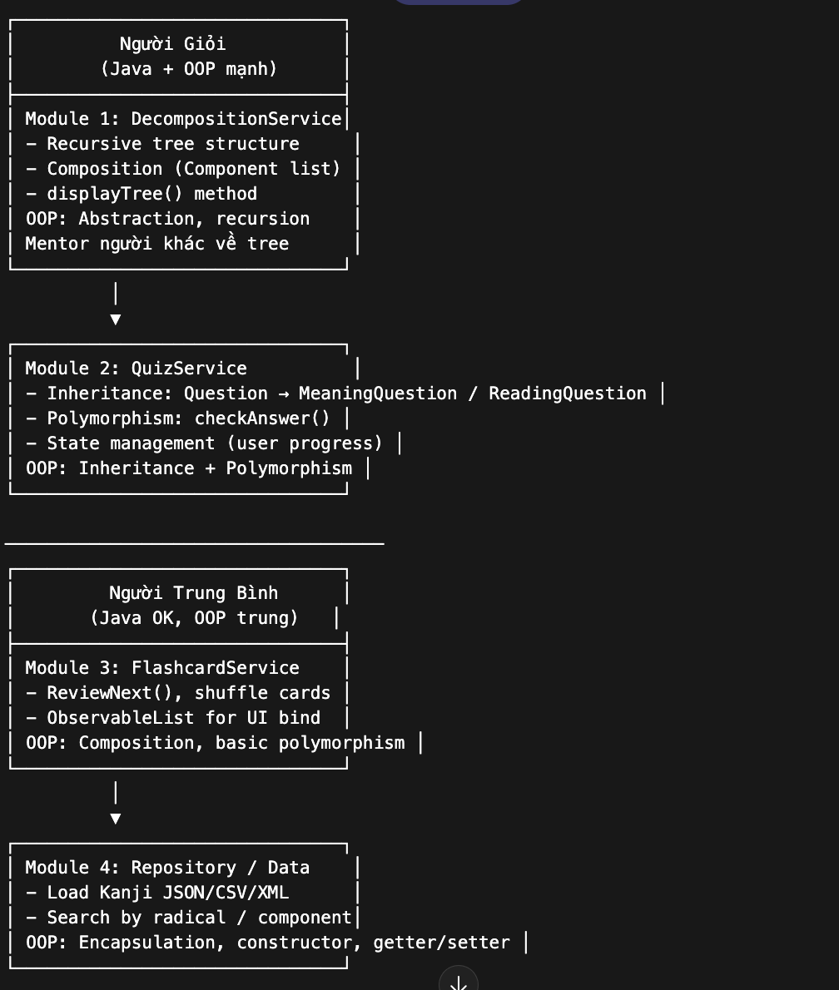
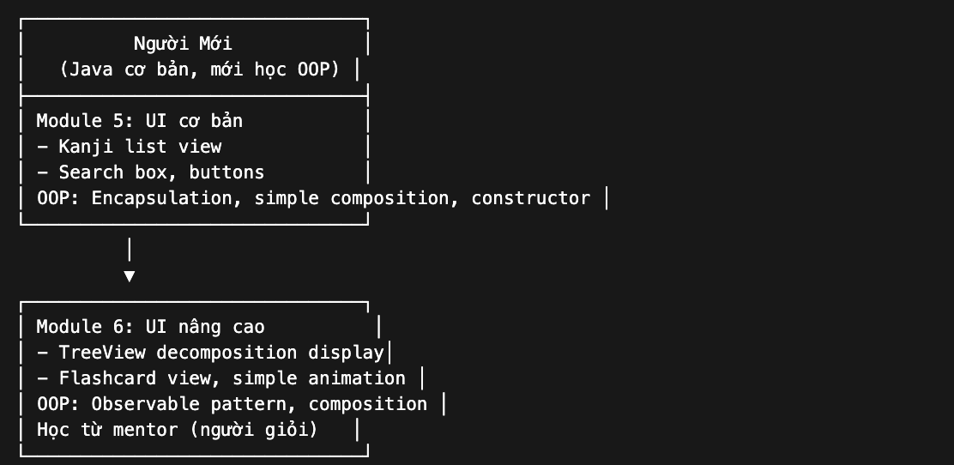

Cơ bản: Frontend: JavaFX (học 1 tí) Java
Backend: Java
Hosting service: GitHUB

Android: Kotlin/
Frontend: XML
Backend: java
Git hub

